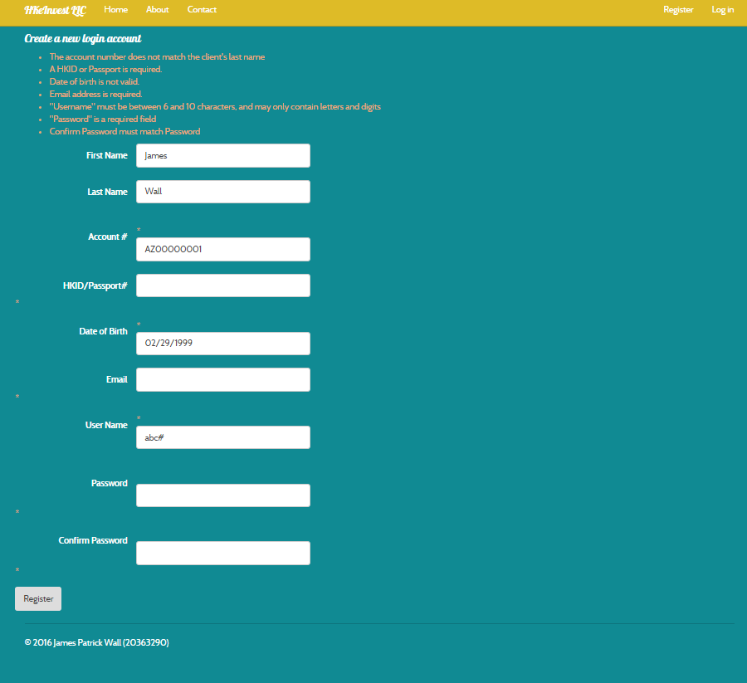

Please note that:

* My regex checks the validation of the password in one pass, not two, which is why there is only one password error
* My regex checks the validation of the username in one pass, not two, which is why there is only one username error
* All of the errors on mine match up to one on the example